Pear #3  Pear Rhubarb Pies  Instructions  - [DOUGH] Stir to combine all ingredients in a medium mixing bowl. Scrape out onto a floured (rye flour) surface and knead until dough is no longer sticky. Add additional flour as needed. Roll into a ball and set aside.  - [TAPIOCA] Prepare tapioca pudding according to box directions, reducing the sugar (only use 3Tbsp.) and milk (slightly less than 2c). Set aside to cool for 20 minutes.  Note: Reduce the sugar to prevent over sweetening the pies. It is possible to use cook & serve tapioca box pudding for a sweeter pie.  - [RHUBARB] Combine all ingredients in a medium pot and cook over medium heat until rhubarb is soft and mixture is like a thick pie filling. Pour into a colander if too watery. Set aside.  - [PEAR] Melt butter in a medium skillet. Core and slice pears (peeled or with skin). Add pears to butter and cook 7 minutes on medium, flipping half way. Dust with cardamom and cinnamon. Mix in brown sugar and water. Option to add raisins here. Add salt and vanilla. Turn heat off, but allow skillet to sit on burner until ready to use.  - [ASSEMBLY] Preheat the oven to 525F (275C). Prepare a cookie sheet with parchment paper.  - Flour work surface and rolling pin. Roll out the dough onto floured surface to about ½in. thick. Use a glass or cookie cutter to cut out 7 rounds. The remaining dough will be the 8th pie. Flatten each round into an oval about the size of a large man’s hand (as big as you want them, so the dough is thin, but not thin enough to tear).  - Add a layer of tapioca pudding, about 1/2c, to the flattened dough. Add rhubarb, about 1/4c, on top of the tapioca. Top with caramelized pears.  - Fold over the long edges so that they almost touch in the middle. Begin crimping at the end, pinching the edges of the dough all the way around. They should look like Finnish karelian pies.  - Melt 2 Tbsp. butter and brush over pies to prevent burning.  - Using a large spatula, gently transfer them to the parchment paper and bake for 12 minutes.  - Allow to cool 5 minutes, then transfer to a cooling rack. | Prep  INgredients  DOUGH  160g dark rye flour  110g wheat (or wheat/AP mix]  3/4c water  Dashes of salt and sugar  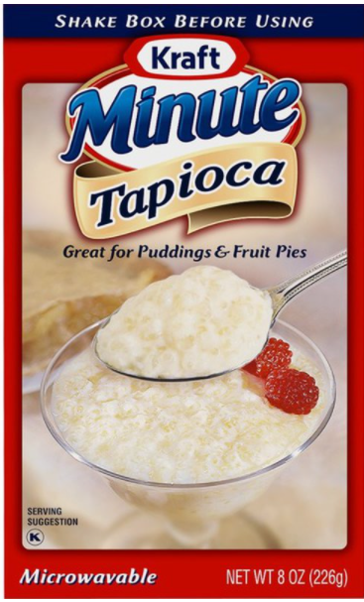  TAPIOCA  Kraft Minute Tapioca,  6 servings prepared, ½ the sugar  +1egg, 2cmilk, 3Tsugar, & 1tvanilla  +mulling spices / cinnamon [optional]  RHUBARB  1c chunked rhubarb (not diced)  1/3c sugar  1 Tbsp. flour  1 Tbsp. cornstarch  1/4c water  1/8c lemon juice (1/2 lemon)  PEAR  2 pears (Bosc or Anjou)  3 Tbsp. butter  Cardamom / cinnamon  ¼c brown sugar  1 Tbsp. water  1/4c raisins [optional]  Dash of salt  1 tsp vanilla extract  2 Tbsp. butter, melted  Time  PREP 40 min  BAKE 12 min  Servings  8 pies

